Data profiling and quality-rule recommendation: where the leading tools stand
A technical comparison of Ataccama ONE, Informatica Data Quality, Collibra Data Quality & Observability and Google Cloud Knowledge Catalog (formerly Dataplex), focused on how each one profiles data, turns profiles into rules, and how far each has moved toward agentic automation.
Status as of 11 September 2026
Sources: vendor documentation, release notes and announcements (78 references)
Audience: engineers building an in-house profile-and-recommend capability

Contents
1. Summary
2. A reference model for profile-and-recommend
3. At a glance
4. Ataccama ONE
5. Informatica Data Quality
6. Collibra Data Quality & Observability
7. Google Cloud Knowledge Catalog (formerly Dataplex)
8. Anomalo
9. Side-by-side comparisons
10. How agentic is each one?
11. Implications for our profile-and-recommend system
12. Caveats
References

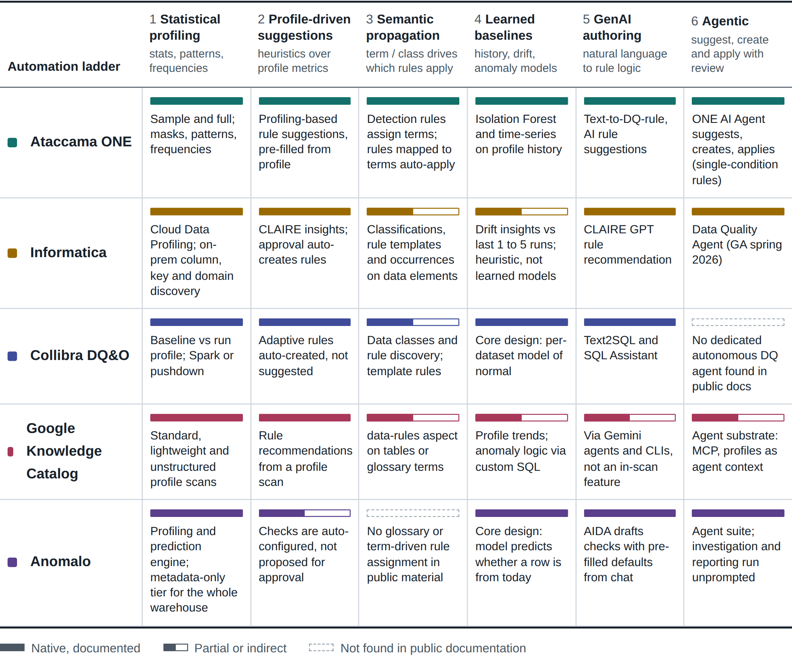
Automation capability matrix. Solid bar: native, documented. Half bar: partial or indirect. Dashed: not found in public documentation.
Author's assessment from the sources in the reference list. Each cell is substantiated in the vendor sections below.

1. Summary
Four of the five products follow the same basic loop: profile the data, derive candidate rules, have a human approve them, execute them on a schedule and score the results by dimension. They differ in where the intelligence sits in that loop. The fifth, Anomalo, rejects the loop and learns what normal looks like instead.
Ataccama ONE is the most complete implementation of the "semantic propagation" pattern. Profiling feeds detection rules that tag attributes with glossary terms, and rules attached to a term are evaluated automatically on every attribute carrying it.^{[6][7]} On top of that it offers profiling-based and AI-based rule suggestions, ML anomaly detection over profile history, and an embedded ONE AI Agent that can suggest, create and apply rules to a table in one instruction.^{[9][10][11]}
Informatica publishes the most transparent recommendation logic. Its CLAIRE "insights" in Cloud Data Profiling are a documented catalogue of column-level heuristics, each with an explicit algorithm and scoring band, and approving an insight automatically creates and applies a rule.^{[20][21]} Governance-side rule templates and rule occurrences in Cloud Data Governance and Catalog tie rules to data elements, and a natural-language Data Quality Agent became generally available in spring 2026.^{[32][37]}
Collibra Data Quality & Observability takes the opposite stance to rule suggestion: it profiles each dataset, learns what normal looks like, and auto-generates adaptive rules that re-calibrate as data changes, so that far fewer rules need to be written by hand.^{[40][46]} Generative AI is used for authoring custom SQL rules (Text2SQL) rather than for autonomous action.^{[49]}
Google Cloud Knowledge Catalog (Dataplex Universal Catalog was renamed on 10 April 2026) offers profile scans that recommend a small set of declarative rule types, rules-as-code in YAML and Terraform, and reusable rules that can be attached to glossary terms as metadata.^{[53][56]} It is not an agentic data-quality product in itself. It is designed as a substrate for agents: MCP servers, profiles consumed as context by Gemini agents, and a Google codelab that uses an LLM agent to turn a profile into a rule file with a human review step.^{[58][59][64]}
Anomalo is the outlier in this group and the closest to a pure machine-learning play. It does not recommend rules for a steward to approve; it learns each table's behaviour and monitors it, using a model that tries to predict whether a record came from today's load, then attributes the anomaly back to specific columns, segments and rows.^{[70]} Explicit checks exist (over 40 no-code check types plus SQL and an API) but are a second layer on top.^{[72]} In April 2026 the company repositioned around a suite of nine agents, of which several are live and several are announced.^{[66]}
The state of the art in one paragraph. Rule recommendation has converged on a two-tier design. A deterministic tier maps profile statistics to rule templates (null ratio of zero suggests a completeness rule, a small stable value set suggests a set check, and so on) and is cheap, explainable and fast. A generative tier, built on an LLM, adds rules the heuristics cannot see, writes rule logic from business language, and in the newest releases plans and applies rules across many tables. Every vendor keeps a human approval step, records the reasoning behind a suggestion, and uses a learning period of several runs before trusting history-based thresholds.

2. A reference model for profile-and-recommend
To compare products that use different vocabulary (monitors, scans, jobs, catalog items, rule occurrences), it helps to map each onto one generic pipeline. The eight stages below are sequential; the dashed arrow is the feedback loop through which run history tunes future thresholds and suggestions.
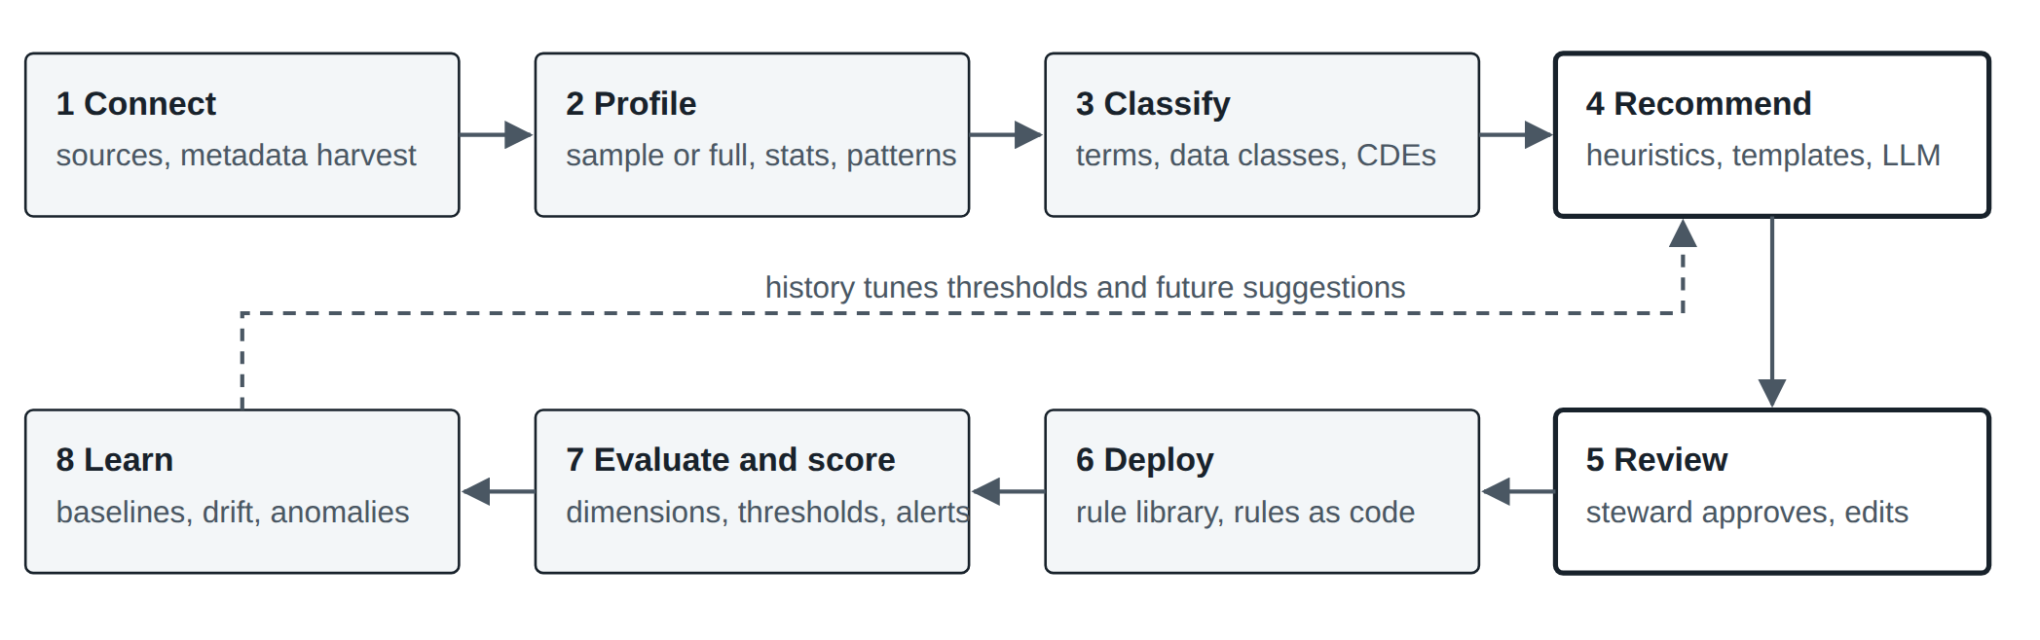
Figure 1. Generic pipeline used throughout this report. Stages 4 and 5 (bold outline) are where the products differ most and where an in-house system has the most design freedom.
Table 1. How each product names the stages of the reference model
Stage | ■ Ataccama ONE | ■ Informatica | ■ Collibra DQ&O | ■ Knowledge Catalog | ■ Anomalo
Unit of data | Catalog item, attribute | Source object, column; data element in CDGC | Dataset (DQ job), column | BigQuery or Iceberg table entry, column | Table, column, segment
Profile | Sample profiling, full profiling (inside a DQ monitor) | Profile run (Cloud Data Profiling); column profile, enterprise discovery (on-prem) | Profile activity of a DQ job; baseline vs run | Data profile scan | Profiling and prediction engine, run per table
Classify | Detection rules, AI term suggestions, glossary terms | Data classifications, data domains | Data classes, sensitive labels, rule discovery | Glossary terms, aspects, data classification | No business glossary layer; domains and ownership metadata
Recommend | Rule suggestions (profiling and AI); ONE AI Agent | CLAIRE insights; CLAIRE GPT; Data Quality Agent | Adaptive rules (auto); Text2SQL for custom rules | Profile-based rule recommendations | Checks auto-configured on monitoring; AIDA drafts checks
Rule object | DQ evaluation rule (ONE expressions), mapped to term or attribute | Rule specification asset; rule template and rule occurrence | SQL rule (freeform, native, template, data class); monitor | DataQualityRule in a DataScan spec; rule template entry | Check (table observability, table anomaly, key metric, validation rule)
Execute | DQ monitor, DQ evaluation; pushdown or DPE | Profile, mapping, scorecard | DQ job, Spark (pullup) or pushdown | Data quality scan in a Google tenant project | Queries pushed to the warehouse; metadata polled hourly
Learn | Anomaly detection on profile versions; time-series analysis | Variation insights across recent runs | Adaptive rules, behaviors, learning state | Profile history; custom SQL | Model of normal per table with dynamic severity threshold

3. At a glance
Table 2. Product surfaces, execution and AI layer
 | ■ Ataccama ONE | ■ Informatica | ■ Collibra DQ&O | ■ Knowledge Catalog | ■ Anomalo
Product lines to be aware of | ONE Agentic (current SaaS), ONE DQ&C, ONE Desktop (plan-based designer), MDM, RDM | IDMC cloud: Cloud Data Profiling, Cloud Data Quality, CDGC. On-prem: Informatica Data Quality 10.x (Analyst, Developer) | DQ&O Classic (self-hosted, OwlDQ heritage) and Data Quality within the unified Collibra Platform (cloud) | Knowledge Catalog (formerly Dataplex Universal Catalog); BigQuery Studio; Gemini data agents | One platform: table observability, deep data quality monitoring, unstructured monitoring, agent suite
Ownership, 2026 | Independent | Informatica from Salesforce | Independent | Google Cloud | Independent, venture-backed
Rule language | ONE expressions; parameters, variables, aggregation and cross-table rules | Rule specifications (visual logic), mapplets, dictionaries | SQL (Spark SQL for pullup, native SQL for pushdown) | Declarative rule types plus GoogleSQL (row condition, table condition, SQL assertion) | No-code check library plus SQL
Where rules run | Ataccama DPEs or pushdown to the source | Secure Agent, elastic or non-elastic mappings, profiles | Spark cluster or pushdown to the warehouse | BigQuery, in a Google tenant project or with a custom execution identity | In the customer warehouse; SaaS or in-VPC deployment
Rules as code | REST API for rules and monitors; move rules between environments | Bulk import templates; REST APIs | REST APIs; rule export | YAML spec, Terraform, gcloud, Python client | REST API, Python client, Airflow provider, MCP server
AI layer | ONE AI (GenAI, ML, ONE AI Agent); MCP Trust Layer for external agents | CLAIRE, CLAIRE GPT, CLAIRE Agents, headless CLAIRE via MCP | Collibra AI (Text2SQL, SQL Assistant, descriptions) | Gemini in BigQuery, Data Engineering Agent, Knowledge Catalog MCP servers | Unsupervised ML engine plus nine-agent suite and AIDA
Gartner ADQ MQ 2026^{[65]} | Leader (5th time), furthest on vision^{[19]} | Leader (18th time)^{[39]} | Not verified for this report | Not verified for this report | Not verified for this report

4. Ataccama ONE
Unified data trust platform: quality, catalog, lineage, observability, reference and master data. Current documentation line: ONE Agentic.

4.1 How it profiles
Ataccama offers two profiling modes. Sample profiling reads a small, owner-configurable sample and computes statistics, patterns, masks and value frequencies as cheaply as possible. Full profiling reads every record and can also run anomaly detection. The documented best practice is to sample everything first, then full-profile the important items and schedule them.^{[1]} In the Agentic line, profiling is configured as part of a DQ monitor, which can run profiling alone or together with DQ evaluation.^{[1]} One execution detail worth noting: sample profiling always runs on Ataccama's own processing engines even when pushdown is configured, because pushdown gives little benefit on small samples.^{[2]}
Results include frequency analysis (how many values are unique or duplicated, with nulls excluded) and per-attribute statistics.^{[3]} The desktop designer (ONE Desktop) exposes a more classical profiling step with advanced analyses: primary-key candidacy, foreign-key matching between inputs, business rules expressed as Boolean expressions, roll-ups over subsets, drill-through to records, and dependency analysis that tests whether dependent columns are determined by a key above a configurable threshold.^{[4][5]}

4.2 Rule model
Two rule types matter. Detection rules assign glossary terms to attributes, either from the data (values match a condition) or from metadata (attribute names).^{[7][16]} A detection threshold sets the share of records that must pass before a term is assigned.^{[16]} DQ evaluation rules measure quality; each belongs to exactly one dimension and can be mapped to a term, in which case it is evaluated on every attribute carrying that term, or applied directly to an attribute.^{[6][7]} Rules support parameters, so one rule can be reused with different bounds, and the platform supports aggregation and cross-table rules.^{[8]} Terms can also be assigned by AI term suggestions after discovery.^{[6]}
Why this matters for recommendation. Once a term such as "email" or "account number" is reliably detected, rule assignment becomes a lookup: every attribute with the term inherits the term's rules. The recommendation problem is pushed upstream into classification, which is easier to automate and audit than open-ended rule generation.

4.3 How it recommends rules
Ataccama documents three recommendation paths.
Profiling-based suggestions are computed on the fly whenever a user opens an Add Rule dialog, at catalog-item and attribute level. AI-based suggestions can be layered on top at attribute level; they take longer and can be switched off in global settings. Suggestions that need parameters or masks arrive pre-filled with values derived from the profile, show a suggestion reasoning and a profile preview, and are applied to the attribute on acceptance. Only users with edit rights (by default data owners and stewards) see them.^{[9]} Users can also build a rule directly from mask, pattern and frequency results in the profile.^{[8]}
The ONE AI Agent can be asked to suggest rules for a named table, basing suggestions on attribute data types and, if enabled, profiling insights. It can then create those rules (saved to the rule library in a published state), apply them to the relevant attributes, or do all three in one prompt. Created rules can be reviewed and tested. Documented limitations: it cannot create rules with parameters or variables, and rules are limited to a single condition with one fallback.^{[10]}
Text-to-DQ-rule generates and debugs rules from natural language. Ataccama states it does not train on customer data or metadata, administrators can disable the features, and (per the generative-AI getting-started page) the features run on OpenAI GPT-4 via Azure AI.^{[13]}

4.4 Anomaly detection and observability
Anomaly detection runs over historical profiling versions of an item using either an Isolation Forest (time-independent) or a time-dependent model. The Isolation Forest scores each profile run against the others across feature categories such as value counts, string and numeric features, most and least frequent values and masks, and needs at least six profiling runs before it activates.^{[11]} A separate time-series analysis for transactional data lets users choose bucket size, window and sensitivity, and shows expected ranges and anomalous points.^{[12]} Anomalies can be accepted or rejected, and structure checks and AI anomaly detection do not count toward the data quality metric.^{[6]} Data observability (freshness and AI anomaly monitoring across a source) requires at least a sample profile first.^{[14]}
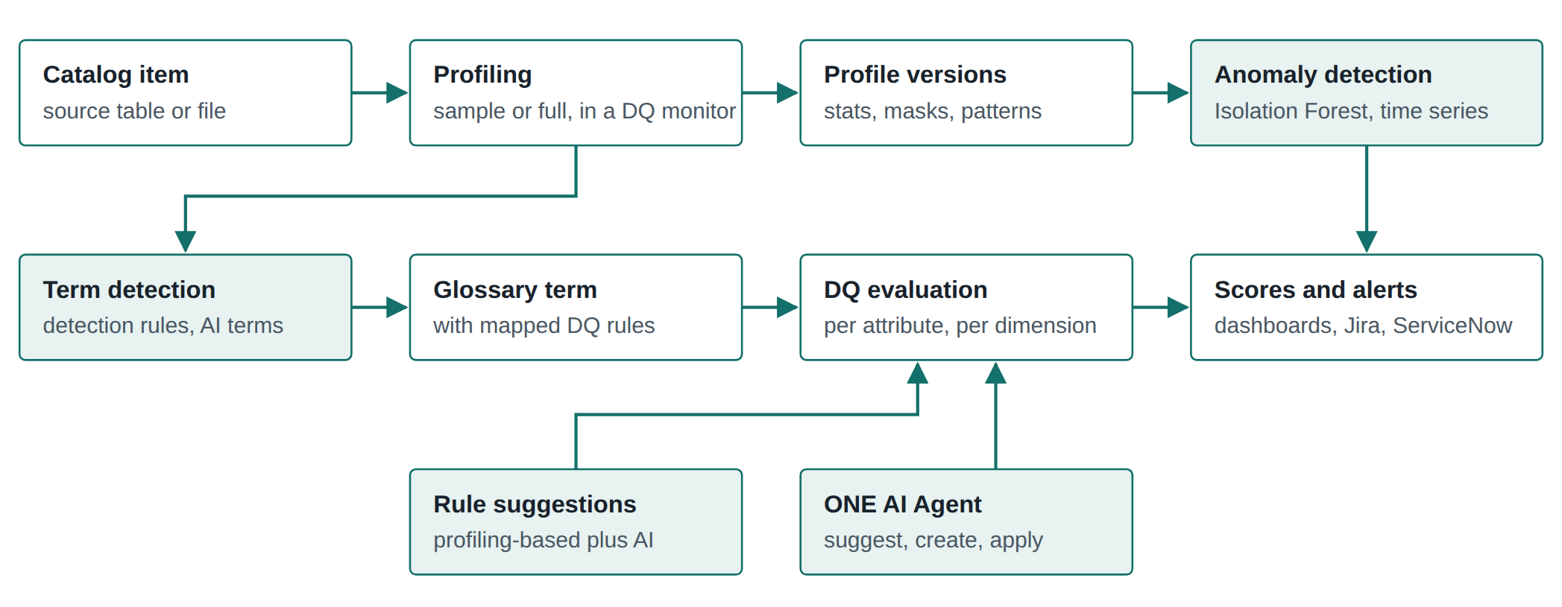
Figure 2. Ataccama. Shaded boxes are the automated inference points. Rules reach attributes either through terms (top path) or through suggestions and the agent (bottom path).

4.5 Enforcement and integration
Beyond scheduled monitors, the Agentic documentation covers DQ firewalls and Data Quality Gates, which run the same rule definitions inside pipelines (locally in Python, or as Snowflake UDFs and DMFs), plus REST APIs for managing rules and monitors and moving them between environments.^{[17]} An MCP Trust Layer exposes the platform to external AI agents.^{[18]} Ataccama markets the ONE AI Agent as a digital data steward that generates rules, suggests where to apply them and detects anomalies.^{[15]}
Table 3. Ataccama strengths and limits for a profile-and-recommend use case
Strengths | Limits and watch-outs
Term-driven rule propagation is mature and auditable. Suggestions carry reasoning and profile-derived parameters. Real ML anomaly detection on profile history. Agent covers the whole suggest-create-apply loop. Rules can be enforced in pipelines, not just monitored. | Agent-created rules are simple (one condition, no parameters). Anomaly model needs six or more runs. Several documentation lines (Agentic, DQ&C, Desktop) with different terminology. GenAI dependency on a third-party LLM may need risk review in regulated settings.

Key docs: Profiling, Rule suggestions, Create DQ rule using AI Agent, Anomaly detection internals, Rule types, Define critical data elements.

5. Informatica Data Quality
Two estates: the cloud Intelligent Data Management Cloud (Cloud Data Profiling, Cloud Data Quality, Cloud Data Governance and Catalog) and the on-premises Informatica Data Quality 10.x. Now branded Informatica from Salesforce.

5.1 How it profiles
On-premises (IDQ 10.x). Profiling in the Analyst and Developer tools covers value frequencies and data types, keys and functional dependencies, primary and foreign key inference, and data domain discovery. Analysts can compare two runs of a column profile, view historical runs and build scorecards.^{[28]} Enterprise discovery runs column profiling and domain discovery across many schemas and connections and produces a consolidated summary including patterns, unique values and data-type conflicts.^{[29]} Data domain discovery can match on column data, column names or both, with a minimum percentage match.^{[30]} Outlier detection flags patterns, values or frequencies outside the range of the majority, on demand.^{[31]}
Cloud (Cloud Data Profiling). Profiles run against source objects and also get rules assigned automatically based on the source object and its attributes, in addition to rules a user attaches from Cloud Data Quality.^{[23]}

5.2 CLAIRE insights: the most transparent recommender
When CLAIRE is enabled on a profile, it analyses each run and proposes insights that a user approves or rejects. If an insight is approved, the profiling and data quality services create a data quality rule and apply it to the profile automatically.^{[20]} Insights are unavailable for Avro, Parquet and JSON sources with hierarchical columns.^{[20]} The same flow is exposed in the REST API, including a runtime flag to enable CLAIRE anomaly detection and a PATCH call to approve or reject insights.^{[22]}
Unusually, Informatica documents the algorithm and scoring band for every insight type. Each type analyses one column independently of the others, using metrics computed on each profile run, and scores the finding High, Medium or Low.^{[21]} Grouped by what they compare against, they form two families.
Table 4. CLAIRE insight types in Cloud Data Profiling (paraphrased and grouped from the vendor documentation^{[21]}; the right-hand column is the author's mapping)
Family | Insight | What it checks (summary) | Rule it points toward
Single run  13 types | Completeness check | Share of null, blank, empty or all-zero values | Completeness rule
Single run  13 types | Uniqueness check | Column is almost but not fully unique (few duplicates, no nulls) | Uniqueness or key rule
Single run  13 types | Column length deviation | Value lengths more than two standard deviations from the mean | Length or format rule
Single run  13 types | Column token deviation | Token counts far from the mean | Format or parse rule
Single run  13 types | Number value distribution | Numeric values outside roughly two standard deviations | Range rule
Single run  13 types | Date validity, date-locale, null date | Invalid date patterns, mixed locale formats, placeholder dates such as all zeros or all nines | Date validity rule
Single run  13 types | Day, month, year distribution | Unusual spread of date parts | Range or plausibility rule
Single run  13 types | Special characters | Characters outside the top 80% of patterns | Pattern or cleanse rule
Single run  13 types | Spelling analysis | Phonetic fingerprints reveal inconsistent spellings of name-like values | Standardization or dictionary rule
Versus history  5 types | Completeness variation | Change in null-like values against a truncated mean of the last five runs | Completeness threshold
Versus history  5 types | Distinct variation | Distinct count up by more than 70% against recent runs | Cardinality monitor
Versus history  5 types | MinMax variance | Min-to-max spread grows by more than 70% (sources over 1,000 rows) | Range rule
Versus history  5 types | Top pattern stability | Share of the dominant pattern drops sharply from the previous run | Pattern rule
Versus history  5 types | Distribution shift | Mean and standard deviation drift over four or more runs | Statistic range rule

For history-based insights, the truncated mean discards the highest and lowest of the last five runs, falls back to a plain mean with fewer than four prior runs, and produces nothing without prior runs.^{[21]}

5.3 Rule model
Cloud Data Quality work is built from assets: cleanse, deduplicate, parse, labeler, rule specification and verifier, plus dictionaries of reference data. Each is used through a matching transformation in a Data Integration mapping.^{[24]} A dimension such as accuracy, consistency, uniqueness or timeliness can be set on an asset, and scorecards read the dimension from the rule specification.^{[25]}
On the governance side, Cloud Data Governance and Catalog separates a rule template (the business definition) from a rule occurrence (that definition applied to a primary data element with a threshold, criticality, dimension and a reference to the technical rule). Informatica runs advisory sessions specifically on the automation options for creating occurrences.^{[32]} Occurrences can be created in bulk from an import template, which is the closest vendor analogue to a spreadsheet-driven rule-writing process.^{[33]}

5.4 Generative and agentic features
CLAIRE GPT can recommend data quality rules for the data elements of a dataset; accepted recommendations become rule occurrences that open in Cloud Data Governance and Quality for review. It also attempts root-cause analysis by identifying which elements and dimensions drag the score down.^{[27]} During mapping design, CLAIRE can also recommend rule specifications.^{[26]}
In November 2025 Informatica described agentic CLAIRE GPT as planning a task, requiring the user to approve the plan before execution, and showing reasoning traces, with a Data Quality Agent in preview that turns natural-language business specifications into rules.^{[34]} At Informatica World in May 2026 the Data Quality Agent was announced as generating production-ready rules from natural language, and CLAIRE was repositioned as a headless multi-agent layer exposed through MCP.^{[35][36]} The Data Quality Agent and headless data management were reported as generally available in spring 2026, with a Metadata Enrichment Agent due in Q4 2026.^{[37]} Salesforce engineering describes agents running on schedules or events to execute quality assessments and rule validation without a user in the conversation.^{[38]}
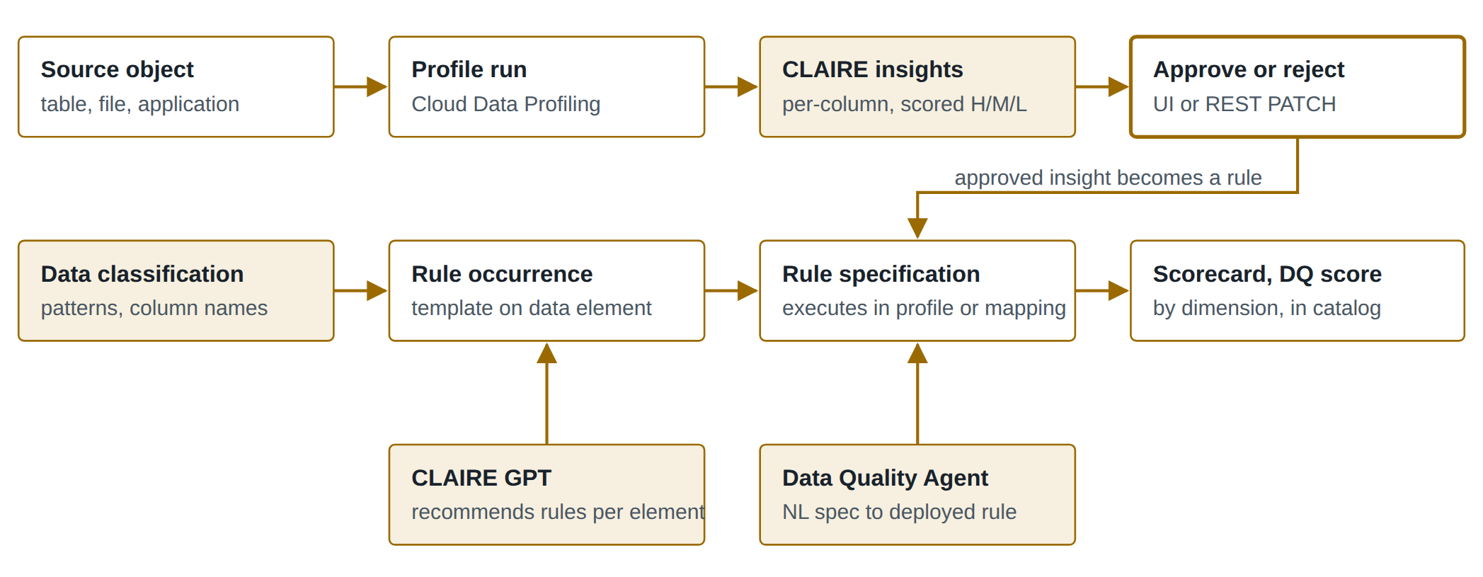
Figure 3. Informatica. The top path is statistical (insights); the middle path is governance-led (templates and occurrences on data elements); the bottom path is generative.
Table 5. Informatica strengths and limits for a profile-and-recommend use case
Strengths | Limits and watch-outs
Fully documented insight algorithms, directly reusable as a design reference. Approve-to-rule loop is automated and API-driven. Template and occurrence model maps well to critical data elements and certification. Broad asset library (cleanse, parse, match, address verification). | History-based insights are fixed heuristics rather than learned models. Recommendation, governance and execution live in separate services. Large gap between on-prem IDQ and cloud capabilities. Agentic features are recent; production evidence is mostly vendor-reported.

Key docs: Insights, Insight types and algorithms, Cloud Data Quality assets, CLAIRE GPT for data quality, IDQ 10.5 profiling.

6. Collibra Data Quality & Observability
Descended from OwlDQ. Available as DQ&O Classic (self-hosted) and as data quality inside the unified Collibra Platform, where it sits alongside catalog, lineage and policy.

6.1 How it profiles
Profiling is on by default when a dataset is onboarded as a DQ job; users can scan the whole table or restrict depth (row filters) and width (columns).^{[45]} The profile page contrasts a historical baseline with the current run, shows the defined type alongside inferred types that deviate from it, and lets users label columns with data classes and sensitivity labels and create quick rules from column insights.^{[44]} Computation happens in Spark by default, or can be pushed down to the warehouse, either as a full profile (everything except TopN) or as counts only; the documented pushdown targets include Snowflake, Redshift, SQL Server, Oracle, PostgreSQL, Teradata, DB2 and others.^{[45]}

6.2 Adaptive rules: learn normal instead of suggesting rules
Collibra's central idea is that a large share of rules never need to be written. When a dataset comes under management, Collibra profiles it and builds a model per dataset of what "normal" looks like. As the data changes, the model re-calibrates rather than requiring users to edit thresholds. Findings appear under Behaviors, and users can remove individual factors (for example stop tracking min and max) from the model.^{[40]} Adaptive rules watch numeric representations of the data over time and down-score values outside learned bounds.^{[41]} The rules documentation states the philosophy plainly: profile, auto-discover and learn first, then add explicit rules only where needed.^{[46]}
In the unified platform these appear as monitors. Out-of-the-box monitors track data type, empty values, execution time, max, mean, min, nulls, row count, schema changes, template rules and uniqueness; user-defined SQL becomes a custom-rule monitor. A monitor is learning until it has four runs with data, then passing or breaking; stewards can pass a breaking adaptive finding (which persists until reset) or suppress a monitor, which removes it from scoring.^{[43]}
Table 6. Collibra detection layers and monitor types
Layer or monitor | What it detects | Configuration
Adaptive rules (behaviors) | Shifts in profile metrics such as row count, nulls, min, max, mean, distinct count | On by default; factors can be excluded^{[40]}
Patterns | Unusual combinations of string values across columns | Default lookback five days^{[42]}
Dupes | Exact or fuzzy duplicate values, case-insensitive | Columns and match type^{[42]}
Schema change | Columns added, altered or dropped | Out-of-the-box monitor^{[43]}
Records and other layers | Record deltas, outliers, duplicates, patterns | Layer settings in job creation^{[51]}
Custom and template rules | Business logic in SQL | Rule workbench, rule templates^{[43][47]}

6.3 Explicit rules and semantic discovery
Explicit rules are SQL. In Classic, freeform rules are Spark SQL for pullup jobs, native rules use the source's own dialect, and pushdown jobs always use native SQL; data-type, data-class and template rules require a primary column.^{[47][48]} Rule discovery detects which data classes in a chosen data category apply to columns, choosing the best match by percent match and name distance when a column matches several.^{[46]} Scores are 0 to 100 with default bands (passing from 90), and notifications fire on thresholds.^{[51]}

6.4 Generative AI
The SQL Assistant for Data Quality writes rule SQL from a plain-language prompt and fixes SQL syntax errors, producing Spark SQL or native SQL according to rule type.^{[48]} Custom rules with Text2SQL reached general availability for the cloud product in October 2025, including a preview of sample breaking records before a job runs.^{[49]} Collibra describes the overall approach as ML-driven, explainable SQL rule generation plus GenAI-assisted business rules.^{[50]}
Naming trap. Collibra's self-hosted release notes refer to a "Data Quality Agent". That is the execution component that runs jobs (for example on Spark on Kubernetes), not an AI agent.^{[52]} In public documentation reviewed for this report, Collibra's generative AI is assistive (authoring and troubleshooting) rather than autonomous.
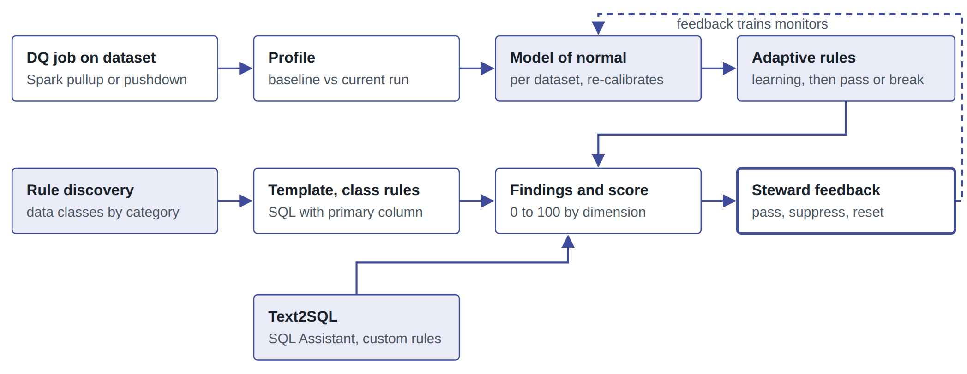
Figure 4. Collibra. Most coverage comes from the top row, which needs no rule authoring. Explicit rules (middle and bottom) cover business logic the model cannot learn.
Table 7. Collibra strengths and limits for a profile-and-recommend use case
Strengths | Limits and watch-outs
Broad coverage with near-zero authoring through learned baselines. Clear monitor lifecycle (learning, passing, breaking, user passed, suppressed) with scoring that honours suppression. SQL everywhere, including pushdown. Tight link from scores to catalog assets and policies. | Adaptive rules detect change, not business correctness; a column that has always been wrong looks normal. Learning period before findings. Less emphasis on recommending explicit, certifiable business rules. Two product lines (Classic and unified) with diverging documentation.

Key docs: Behaviors, Monitors, Rules and rule discovery, SQL Assistant, Profile.

7. Google Cloud Knowledge Catalog (formerly Dataplex)
Dataplex Universal Catalog was renamed Knowledge Catalog on 10 April 2026; API, client library, CLI and IAM names did not change, so code still says dataplex.^{[53]}

7.1 How it profiles
Profile scans run on BigQuery and Iceberg REST Catalog tables and report common values, distributions and null counts, and they recommend data quality rules.^{[55]} There are three modes. Standard mode allows scope, filters and sampling. Lightweight mode fixes those settings and does not support views or external tables. An unstructured mode (preview) uses Gemini on BigQuery object tables to infer business entities and relationships from files such as PDFs and attaches a graph profile to the catalog entry.^{[55]} Profiles cannot look inside nested or repeated fields, which is why Google's own codelab flattens nested tables into materialized views before profiling.^{[58]}

7.2 Rule model
A data quality scan is a DataScan of type data quality on one table. Rules come from profile recommendations, built-in rule types, system rule templates, custom SQL or reusable templates.^{[53]} Row-level rules evaluate each row against a passing-threshold percentage; aggregate rules evaluate one value for the table.^{[53]}
Table 8. Knowledge Catalog built-in and SQL rule types^{[53]}
Rule type | Level | Purpose
NonNullExpectation | Row | Values are not null
RangeExpectation | Row | Value between min and max, optional strict bounds and null handling
SetExpectation | Row | Value belongs to a given set
RegexExpectation | Row | String matches an RE2 regular expression
Uniqueness | Aggregate | All values distinct
StatisticRangeExpectation | Aggregate | Mean, min or max within range
Row condition (SQL) | Row | Boolean SQL per row; can reference other tables for referential checks
Table condition (SQL) | Aggregate | Boolean SQL once per table, with subqueries allowed
SQL assertion | Aggregate | Query returns invalid rows; any row fails the rule

Every rule carries a dimension: freshness, volume, completeness, validity, consistency, accuracy or uniqueness. The limitations section describes the choice as fixed to these seven, while a note allows custom dimension names through gcloud or the REST API.^{[53]} Useful engineering details include a ${data()} parameter that refers to the source table with its filters, sampling and incremental scope; optional debug queries that return diagnostic values when a rule fails; AIP-160 filters that select which rules run by name, dimension, column, threshold or custom attributes; full or incremental scope; custom execution identities; and a limit of 1,000 rules per scan.^{[53]}
Rules can also be treated as metadata. Custom rule templates are catalog entries, system templates cover common checks, and a data-rules aspect can attach rules to BigQuery tables or to business glossary terms.^{[53][56]} Results can be exported to BigQuery, published to the table's catalog entry as a data-quality-scorecard aspect, and alerted on through Cloud Logging or email; a generated query returns the failing records.^{[53]} Scans can be managed as code with Terraform, Cloud Build and GitHub.^{[57]}

7.3 How it recommends rules
Recommendations come from a completed profile scan: the user selects a profile and receives candidate rules, each with a dimension and a passing threshold, for example a set check that limits a categorical column to the values observed.^{[63][54]} This is a deterministic, profile-to-template mapping, and it is not available from the gcloud CLI.^{[53]}

7.4 Is it agentic?
Short answer: the catalog itself is not an autonomous data-quality agent, but it is built to be driven by agents.
The Data Engineering Agent (generally available since June 2026) builds and fixes pipelines from natural language, and can pull sample rows and Knowledge Catalog profile scans as context; it cannot execute pipelines itself.^{[59][60]} Knowledge Catalog exposes local and remote MCP servers so any agent can query metadata, and data insights generate descriptions, relationship graphs and example queries automatically.^{[64][61]} Google positions the whole stack as an "agentic data cloud" with MCP as the universal interface.^{[62]}
The clearest picture of Google's intended pattern is its July 2026 codelab: run profile scans programmatically, export the profile as JSON, have a CLI agent propose a rule plan with a metric-based justification per rule and warnings about volatile metrics, have a human correct and approve the plan, have the agent emit a YAML rule file, then deploy it as a scan.^{[58]} That is essentially a reference implementation of an LLM rule recommender with human review.
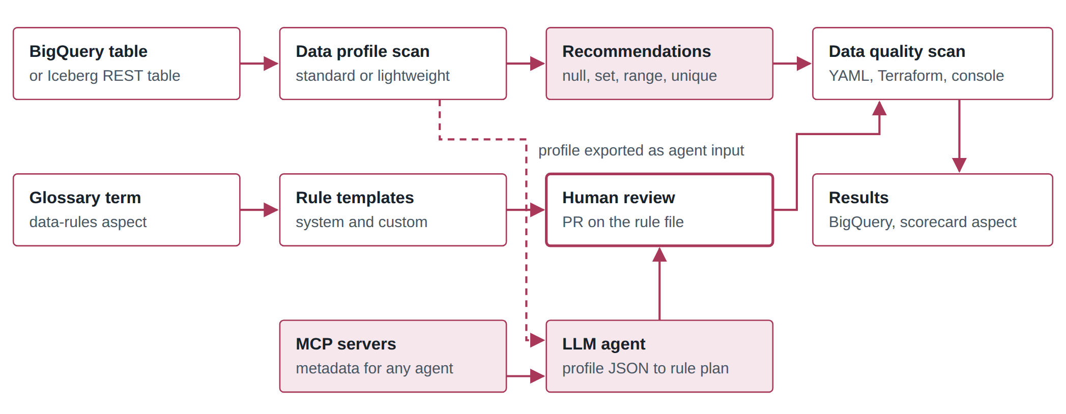
Figure 5. Knowledge Catalog. Deterministic recommendations (top) and the agent pattern from Google's codelab (bottom, dashed input) both end in a declarative scan definition that a human reviews.
Table 9. Knowledge Catalog strengths and limits for a profile-and-recommend use case
Strengths | Limits and watch-outs
Fully managed and native to BigQuery with no infrastructure. Clean declarative rule schema that is easy to generate and diff. Rules can be attached to glossary terms as metadata. Results land in BigQuery for custom reporting. Open agent interfaces (MCP, Python client) make it a good execution target for an in-house recommender. | Only BigQuery and Iceberg REST tables for DQ. Small built-in recommender with no learned baselines or anomaly models in the DQ scan itself. No nested-field profiling. No native cleansing or matching. The rule recommendation step is not in the CLI.

Key docs: Auto data quality overview, About data profiling, Reuse data quality rules, System rule templates, Rules as code, Programmatic DQ codelab.

8. Anomalo
Founded 2021. A machine-learning-first data quality and observability platform for warehouses and lakehouses, repositioned in April 2026 as an agent suite under the banner "Self-Driving Data".
Anomalo belongs in this comparison as the counter-example. The other four products treat rule recommendation as the core problem: profile the data, propose rules, get a human to approve them. Anomalo argues that approach does not scale, and quantifies the claim: at 50 columns per table and five rules per column, a warehouse with a thousand important tables implies roughly 250,000 rules to maintain.^{[69]} Its answer is to learn each table's behaviour and monitor for structural change, treating explicit rules as a targeted supplement.

8.1 Coverage tiers
Monitoring is layered so that cost matches importance. Table observability polls table metadata (by default hourly) and checks four things without querying the data itself: the table or view still exists, no columns were dropped in the last 24 hours, the table was updated within its historically expected window, and the row count is not below the expected level given past behaviour.^{[68]} Because it reads metadata rather than rows, it can be switched on across an entire warehouse cheaply, after which deep monitoring is enabled selectively on the tables that matter.^{[71]}
On a deeply monitored table, scheduling is chained: a freshness check runs first to establish that the day's data has arrived, a volume check then confirms the load is complete, and the remaining checks run afterwards.^{[72]}
Table 10. Anomalo's four monitoring pillars^{[67]}
Pillar | What it is | Who configures it | Catches
Table observability | Metadata checks for existence, schema, freshness and volume | Nobody; on by default per table | Late, missing or truncated loads; dropped columns
Validation rules | Row-level expectations from a no-code library or SQL | Human, per column | Known, specific business violations
Key metrics | Time-series forecasts of a chosen metric, with bounds that widen or narrow with expected variability | Human, per metric | Known unknowns: a metric moving outside its seasonal norm
Unsupervised machine learning | A model of the table's normal structure, run automatically | Nobody | Unknown unknowns: distribution shifts, category changes, broken column relationships

Anomalo's framing is that no single pillar is sufficient and that time-series forecasting alone, which several observability tools market as machine learning, only covers metrics a human already thought to define.^{[73]}

8.2 How the anomaly model works
The mechanism is unusual enough to describe precisely, because it is the most directly borrowable idea in this report. Instead of modelling each column's distribution, Anomalo trains a classifier to answer one question: can it tell whether a given record came from today's data or from an earlier day? If the model can separate today from history with confidence, today's data is structurally different and something has probably changed.^{[70]}
The published implementation sketch has four parts.^{[70]} Sampling: random rows from today plus several lookback dates (yesterday, the same weekday last week, and others chosen for seasonality), around 10,000 rows in total even for very large tables, drawn with a two-stage approach so the warehouse never materialises the whole table to sample it. Feature encoding: strings and timestamps are converted automatically, with encoders chosen per column, including numeric, frequency (replace a value with how often it occurs), is-null, second-of-day and time-delta, and one-hot. Model: gradient-boosted decision trees, chosen for small-sample training, speed at inference, generalisation across tabular data and having few parameters that matter. Explainability: SHAP values attribute the prediction down to individual cells, which drives the severity score, the choice of visualisation and the root-cause breakdown.
Two variants run automatically on a monitored table: a constrained model looking only for a jump in null values, run at high priority because it usually means missing data, and the full model, which detects changes in continuous distributions, categorical values, time durations and relationships between columns.^{[69]} Severity is compared against a threshold learned per table from how noisy that table normally is, and the threshold starts at maximum for a newly configured table.^{[70][72]}
Why the root-cause step matters. In Anomalo's worked example, zero values are injected into a ticket-count column for 30% of rows on one date, but only where the state is New York. The check fails, names the column, and reports that 100% of anomalous rows are in New York against 29.8% of the population.^{[69]} A second example shuffles a price column so its distribution is unchanged but its relationship to other columns is broken, which distribution-based checks cannot see at all.^{[69]} Neither issue would be caught by a rule nobody wrote, and the second would not be caught by a per-column profile comparison either.
Anomalo is candid about what this model deliberately does not do: identify individual bad records (use validation rules), run in real time, find pre-existing problems in historical data, monitor tables with no timestamp, or report outliers, on the grounds that an extreme value is not by itself wrong. The stated sensitivity target is issues affecting at least 1% of the data.^{[70]}
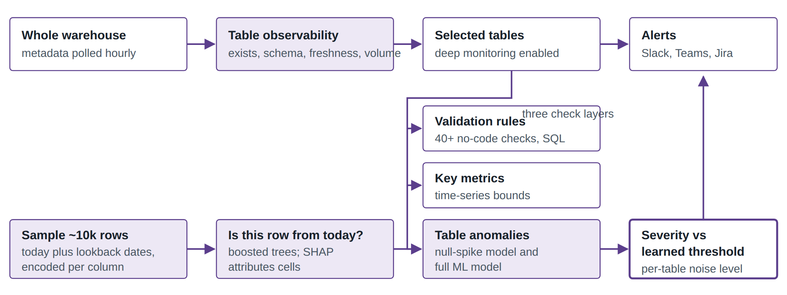
Figure 6. Anomalo. Shaded boxes need no configuration. The bottom row is the classifier that produces the table-anomaly checks; the middle column shows the human-authored layers that sit alongside it.

8.3 Explicit checks
Where a specific expectation matters, Anomalo offers more than 40 no-code check types, each with its own thresholds, options and constraints, plus arbitrary SQL through the API for anything the library does not cover.^{[72][71]} The product also generates a visual profile of a table's columns, expected values and historical changes, which is what the checks and the conversational agent draw on.^{[72]} Independent review notes the flip side: the check library is strong for standard validation but thinner for layered policy logic or heavily domain-specific rules, and unsupervised detection can flag benign seasonal shifts.^{[74]}

8.4 The agent suite
In April 2026 Anomalo announced nine agents built on the same profiling and prediction engine, with the platform deployable in-VPC or as SaaS and able to use a customer-chosen frontier model.^{[66]} Four are described as live or in preview and five as forthcoming.
Table 11. The Anomalo agent suite as announced^{[66]}
Agent | Status at announcement | What it does
Table Observability | Generally available | Continuous availability, freshness and schema monitoring
Data Quality | Generally available | The original engine: define good data in natural language, monitor for deviation
Conversational Analytics (AIDA) | Generally available | Questions, SQL, visualisations, and the control surface for the other agents
Data Insights | Preview | Investigates notable changes unprompted and writes an analyst-style report
Data Documentation | Preview | Builds table documentation from wikis, chat, schema metadata and profiles
Data Issue First Responder | Announced | Triages alerts against runbooks, opens tickets, escalates; actions logged
Dashboarding and Reporting | Announced | Builds dashboards from natural language
Business KPI Monitoring | Announced | Monitors business metrics defined in natural language
Experiment Evaluation | Announced | Evaluates A/B tests, applying the statistics and segment breakdowns

Two details are relevant to rule recommendation. First, AIDA can create checks directly out of a conversation, recommending sensible defaults, pre-filling the configuration and linking the check back to the dataset, which is the closest thing Anomalo has to a rule suggestion workflow.^{[75]} Second, corrections a user gives AIDA are retained as organisational context and applied to future output, which is a feedback loop the other products do not advertise.^{[75]}
Anomalo is also reachable by external agents. It publishes an MCP server on PyPI that exposes curated tools rather than a raw REST wrapper, works with Claude Desktop, Cursor and other MCP clients, and ships as a Gemini CLI extension; there is also a Python client and an Airflow provider.^{[76][77]}

8.5 Unstructured data
For document collections, Anomalo uses LLMs to inspect content directly, screening against standards such as relevance, completeness, bias and toxicity, so that flawed inputs do not reach training sets.^{[71]} A published account of the implementation describes automated OCR and parsing, continuous observability over the extracted content, PII detection and custom metadata extraction rules, with the LLM inference running on a managed cloud service.^{[78]} This is the one place where an LLM, rather than a statistical model, does the actual quality evaluation.
Table 12. Anomalo strengths and limits for a profile-and-recommend use case
Strengths | Limits and watch-outs
The clearest published design for learned, rule-free coverage, including sampling, encoding, model choice and cell-level attribution. Root-cause output names the column, the segment and the contributing rows. Cheap metadata tier makes whole-warehouse coverage affordable. Deploys in-VPC with a customer-chosen model. Open agent interfaces (MCP, Gemini CLI, Python, Airflow). | Not a governance tool: no business glossary, term-driven rule assignment, certification workflow or rule-occurrence model, so it does not by itself answer "which rules cover this critical data element". Needs a timestamp and forward-looking history; will not audit data that was always wrong. Aimed at issues affecting 1% or more of rows. Seasonal shifts can read as anomalies. Several agents are announced rather than shipped, and most performance claims are vendor-reported.

Key sources: Platform overview, Four pillars, How the ML model is built, Unsupervised data monitoring walkthrough, Self-Driving Data and the agent suite, Anomalo MCP server.

9. Side-by-side comparisons

9.1 Profiling
Table 12. Profiling capabilities
 | ■ Ataccama | ■ Informatica | ■ Collibra | ■ Knowledge Catalog | ■ Anomalo
Modes | Sample (owner-set size) and full^{[1]} | Column profile with sampling options; enterprise discovery across schemas^{[29][30]} | Full or filtered by rows and columns; limits by time^{[45]} | Standard (scope, filter, sample), lightweight, unstructured preview^{[55]} | Metadata tier for all tables; deep profiling on selected tables^{[68]}
Column statistics | Stats, masks, patterns, frequencies, uniqueness groups^{[1][3]} | Value frequencies, patterns, data types, nulls, distinct^{[28]} | Baseline vs run metrics, inferred vs defined type, shapes^{[44]} | Nulls, distinct, top values, distribution, quartiles^{[55]} | Column profile of values, expected values and historical change^{[72]}
Structural analysis | Primary and foreign keys, dependencies, roll-ups (Desktop)^{[4][5]} | Keys, functional dependencies, PK and FK inference (on-prem)^{[28]} | Duplicates and patterns across columns as layers^{[42]} | Relationship graphs via data insights (catalog feature)^{[61]} | Column relationships learned by the model rather than declared^{[69]}
Semantic detection | Detection rules on data or names; AI term suggestions^{[6][7]} | Data domain discovery on data, names or both; classifications in CDGC^{[30]} | Data classes; rule discovery by percent match and name distance^{[46]} | Data classification; glossary terms and aspects^{[55]} | Not a documented feature
Pushdown | Yes for full profiling; sample runs on DPE^{[2]} | Depends on runtime and connector | Full profile or counts only on major warehouses^{[45]} | Native (runs in BigQuery) | Queries run in the warehouse; sampling designed to limit cost^{[70]}
History use | Profile versions feed anomaly detection^{[11]} | Compare runs; variation insights over last five runs^{[21][28]} | Baseline model per dataset^{[40]} | Profile job history; export to BigQuery | Central: lookback dates train the model and set thresholds^{[70]}

9.2 Recommendation mechanisms
Across the five products there are five distinct ways a rule gets proposed. An in-house system can combine them; they are complementary rather than competing.
Table 13. How rules get proposed
Mechanism | Input | ■ Ataccama | ■ Informatica | ■ Collibra | ■ KC | ■ Anomalo
Profile heuristics | Single-run statistics | Profiling-based suggestions with pre-filled parameters^{[9]} | CLAIRE single-run insights^{[21]} | Quick rules from profile^{[44]} | Profile recommendations^{[54]} | Not used to propose rules
Semantic propagation | Term or class on a column | Rules mapped to terms^{[7]} | Templates and occurrences on data elements^{[32]} | Data-class and template rules^{[46]} | data-rules aspect on terms^{[56]} | Not documented
History and drift | Multiple runs | Isolation Forest, time series^{[11][12]} | Variation insights^{[21]} | Adaptive rules^{[40]} | Custom SQL only | Table anomaly checks, on by default^{[69]}
LLM from language | Business description | Text-to-DQ-rule^{[13]} | Data Quality Agent^{[36]} | Text2SQL^{[49]} | External agent | Checks defined in natural language via AIDA^{[75]}
LLM from profile and metadata | Profile plus schema | AI rule suggestions, ONE AI Agent^{[9][10]} | CLAIRE GPT recommendations^{[27]} | Not documented | Codelab pattern^{[58]} | AIDA pre-fills check configuration from the profile^{[75]}

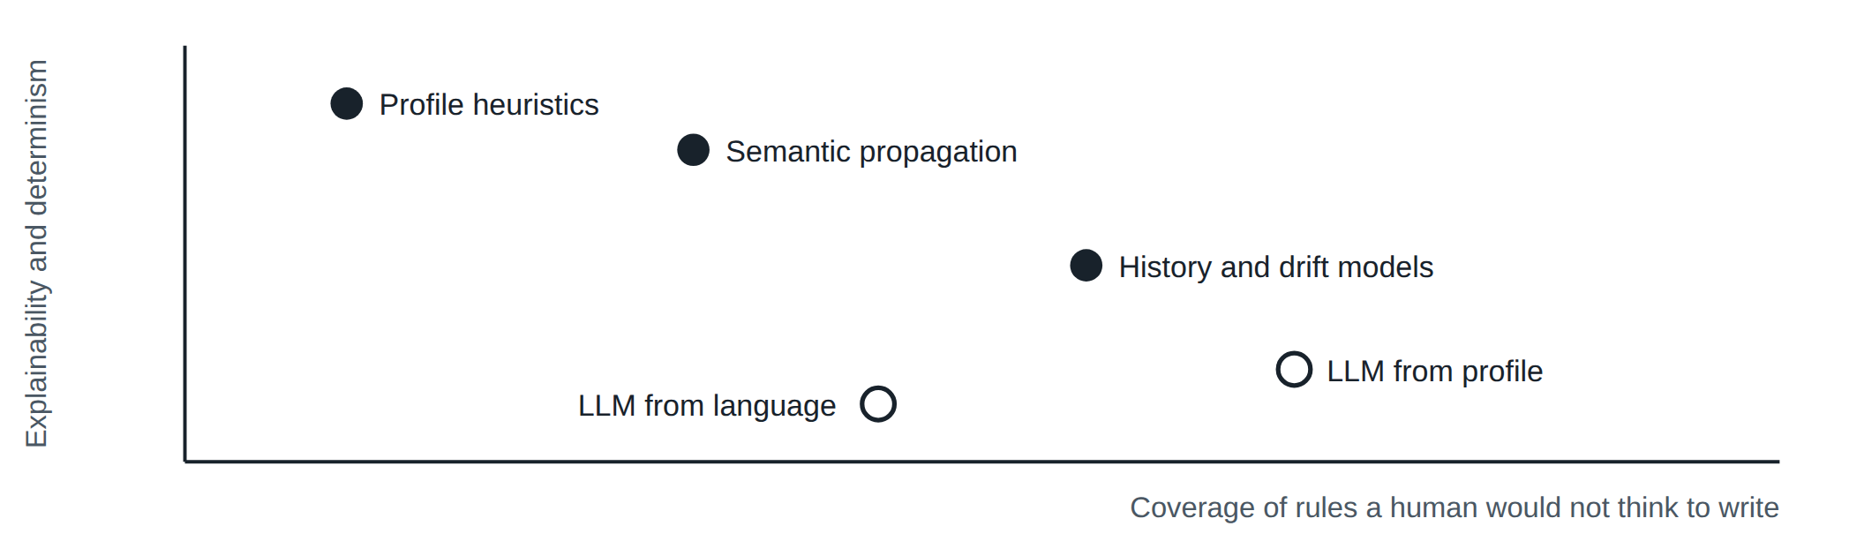
Figure 7. Author's qualitative placement. Deterministic mechanisms (filled) are easy to audit but only find what their templates encode. Generative mechanisms (hollow) widen coverage but need review and grounding in the profile.

9.3 Rule authoring and execution
Table 14. Rule authoring
 | ■ Ataccama | ■ Informatica | ■ Collibra | ■ KC | ■ Anomalo
Logic | ONE expressions with inputs, parameters, variables^{[8]} | Rule specification asset; dictionaries^{[24]} | SQL (Spark or native)^{[48]} | Typed rules and GoogleSQL^{[53]} | No-code check library plus SQL^{[72]}
Reuse | Rule library; parameterized rules; term mapping | Rule templates and occurrences; mapplets | Rule templates | Rule templates, system templates, data-rules aspect | Check templates applied per table
Multi-column and cross-table | Multi-input, aggregation, cross-table rules | Mapping logic | Secondary datasets in SQL^{[47]} | Row or table condition with subqueries | Learned by the model; SQL for explicit cases
Thresholds | DQ thresholds per rule and dimension | Occurrence threshold, criticality^{[33]} | Points and percent scoring; score bands^{[46]} | Passing threshold per row-level rule | Dynamic severity threshold from table noise^{[72]}
In-pipeline enforcement | DQ gates and firewalls^{[17]} | Rule specification transformation in mappings^{[24]} | Job runs in pipeline via API | Scan trigger in pipeline; Terraform^{[57]} | Airflow provider and API trigger checks in pipelines^{[77]}

9.4 Dimensions
Table 15. Out-of-the-box data quality dimensions
Product | Dimensions | Custom
■ Ataccama | Configurable global dimensions (see Data Quality Dimensions); each rule belongs to exactly one^{[6]} | Yes
■ Informatica | Built-in set assigned on assets, including accuracy, consistency, uniqueness and timeliness^{[25]} | Yes (CDGC)
■ Collibra | Accuracy, completeness, consistency, integrity, validity, duplication^{[43]} | Yes
■ Knowledge Catalog | Freshness, volume, completeness, validity, consistency, accuracy, uniqueness^{[53]} | API and CLI only
■ Anomalo | Organised by monitoring pillar rather than by named dimension^{[67]} | n/a

10. How agentic is each one?
"Agentic" is used loosely in marketing. For this report it means software that, given a goal, plans a sequence of actions across the platform (suggest, create, apply, test) and executes them, with a human approving either the plan or the outcome. By that standard, three of the five products ship a data-quality agent today, one offers assistive generative AI only, and one provides the substrate for others to build agents. Anomalo goes furthest in one respect: its Data Insights Agent starts an investigation with no human prompt at all.^{[66]}
Table 16. Agentic capability as of September 2026
 | Agent | What it does on its own | Human control | External agent interface
■ Ataccama | ONE AI Agent | Suggests rules for a table from types and profile insights, creates them in the library and applies them to attributes, in one prompt if asked^{[10]} | Review changes and test after creation. Created rules are published immediately, so review is after the fact^{[10]} | MCP Trust Layer^{[18]}
■ Informatica | Data Quality Agent, CLAIRE Agents | Turns natural-language specs into production rules; agents can run assessments on schedules or events^{[35][38]} | Plan approval before execution and visible reasoning traces in agentic CLAIRE GPT^{[34]} | Headless CLAIRE and data services via MCP^{[37]}
■ Collibra | None found for DQ | Text2SQL and SQL Assistant draft and fix rule SQL on request^{[48][49]} | User writes, previews and saves every rule | Not documented for DQ
■ Anomalo | Nine-agent suite | Monitors, and (in preview) investigates changes unprompted and writes an analyst-style report; First Responder for triage is announced^{[66]} | AIDA is the conversational control surface; agent actions logged^{[66]} | MCP server, Gemini CLI extension^{[76]}
■ Knowledge Catalog | Data Engineering Agent (pipelines), custom agents | Builds and fixes pipelines using profiles as context; does not run pipelines; no dedicated DQ agent^{[59]} | Review generated code; codelab adds plan-then-generate review^{[58]} | Local and remote MCP servers^{[64]}

The vendor claims around agents (for example Informatica's statement that customers previously managed only four or five rules a week) are self-reported and not independently verified.^{[36]}

11. Implications for our profile-and-recommend system
The products above suggest a design that is neither purely statistical nor purely generative. For a workflow centred on critical data elements, where rules are drafted, reviewed by owners and then bulk-loaded into a rule engine, the most transferable ideas are the following.
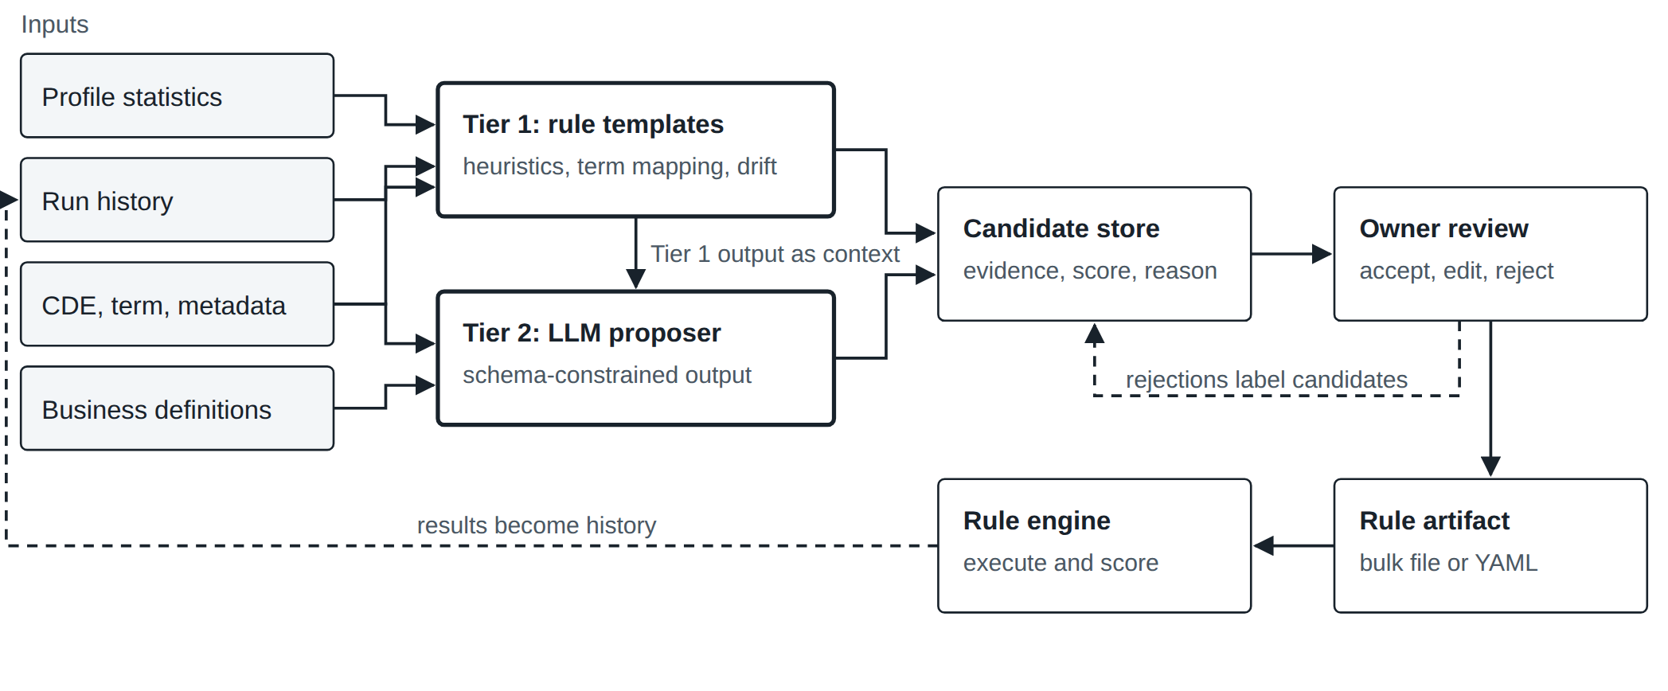
Figure 8. Proposed architecture, synthesised from the patterns above. Tier 1 is deterministic and runs everywhere; Tier 2 fills gaps and is always grounded in Tier 1 evidence. Nothing reaches the rule engine without an owner decision.
Table 17. Patterns worth adopting
Pattern | Seen in | How to apply it
Two tiers: deterministic first, LLM second | Ataccama (profiling plus AI suggestions), Informatica (insights plus CLAIRE GPT)^{[9][27]} | Seed Tier 1 with a catalogue of heuristics like Table 4 and the rule types in Table 8. Call the LLM only for columns and dimensions Tier 1 cannot cover, and pass it the Tier 1 evidence.
Classify first, then map templates | Ataccama terms, Informatica occurrences, KC data-rules aspect^{[7][32][56]} | Treat the recommendation unit as a pair of CDE (or term) and dimension. Attach rule templates to the term once and let every mapped column inherit them.
Parameters come from the profile, not the model | Ataccama pre-filled masks and parameters; Google codelab^{[9][58]} | Let the LLM choose the rule type and justification; compute sets, ranges and regexes from profile data. Flag overfitting risks such as exact row counts or single-value domains.
Explicit evidence and reasoning | Ataccama suggestion reasoning; Informatica score bands; codelab metric justification^{[9][21][58]} | Store for every candidate the metric, value, threshold band and a short rationale. Owners review faster when the evidence is shown next to the rule.
Learning period before drift rules | Collibra four runs, Ataccama six runs, Informatica truncated mean of five^{[43][11][21]} | Do not suggest history-based thresholds until enough runs exist; use a robust statistic such as a truncated mean.
Separate change detection from correctness | Collibra adaptive rules vs custom rules^{[46]} | Keep observability monitors (volume, nulls, schema) out of certification scope; certify explicit business rules only.
Review states and feedback | Collibra user-passed and suppressed states; Informatica approve or reject API^{[43][22]} | Model candidate states (suggested, accepted, edited, rejected, suppressed) and log reasons. Rejections become labelled data to tune heuristics and prompts.
Rules as reviewable artifacts | KC YAML and Terraform; Informatica bulk import template^{[57][33]} | Emit accepted rules as a versioned file matching the target engine's bulk format. Informatica's occurrence template fields (name, description, criticality, dimension, threshold, primary data element, technical rule reference) are a useful checklist.
Constrain what agents may create | Ataccama agent limited to single-condition rules^{[10]} | Start agents on template filling and simple predicates. Unlike Ataccama's agent, keep generated rules in draft until an owner accepts them.
Model "is this row from today?" instead of per-column baselines | Anomalo^{[70]} | One classifier per table, trained on a sample of today plus lookback dates, catches distribution shifts and broken column relationships that per-column checks miss. Use SHAP-style attribution so a failure names the column, segment and rows.
Tier coverage by cost | Anomalo metadata tier^{[68]}, Collibra pushdown | Run cheap metadata checks (existence, schema, freshness, row count) everywhere, and reserve row-level profiling and rules for critical data elements.
Use the platform as execution substrate | Knowledge Catalog scans, MCP, Python client^{[53][64]} | If the target data sits in BigQuery, profile scans can supply Tier 1 inputs and scans can execute accepted rules, while recommendation logic stays in-house.

12. Caveats
This report relies on public documentation, which varies by version and product line (Ataccama ONE Agentic vs DQ&C vs Desktop; Collibra Classic vs unified; Informatica cloud vs on-premises 10.x). Features described for one line may not exist in another. Announcement-stage capabilities, particularly agents launched in 2026, may differ from what a given tenant has enabled. Matrix ratings and Figure 7 are the author's judgement. Where a capability is marked "not found", it means it was not located in the sources reviewed, not that it does not exist. Anomalo publishes no public product documentation site comparable to the other four, so its section leans more heavily on vendor blog and product pages, which are promotional in tone even where the technical content is specific. Vendor demos should be used to confirm anything decision-critical, especially for regulated use where LLM hosting, data residency and model risk management apply.

References

Ataccama
[1] Profiling, Ataccama ONE Agentic
[2] Run Profiling, ONE DQ&C
[3] Understand Profiling Results, ONE DQ&C
[4] Configure the Profiling Step, ONE Desktop
[5] Advanced Analyses, ONE Desktop
[6] Data Quality Overview, ONE DQ&C
[7] Rule Types: DQ and Detection, ONE DQ&C
[8] Create DQ Evaluation Rule
[9] Rule Suggestions
[10] Create DQ Rule Using AI Agent, ONE Agentic
[11] Anomaly Detection: Behind the Scenes
[12] Time Series Data
[13] Get Started with Generative AI
[14] Data Observability, ONE DQ&C
[15] Ataccama ONE AI (product page)
[16] A Beginner's Guide to Data Quality, Part 2 (Ataccama Community)
[17] Data Quality Gates, ONE Agentic (see also DQ Firewalls)
[18] External AI Agents (MCP Trust Layer), ONE Agentic
[19] Ataccama named a Leader in 2026 Gartner MQ for Augmented Data Quality (17 Feb 2026)

Informatica
[20] Insights, Data Profiling
[21] Insights: types, algorithms and scores, Cloud Data Profiling
[22] Enable CLAIRE insights (REST API tutorial)
[23] Rules, Data Profiling
[24] Assets, Cloud Data Quality
[25] Dimensions of data quality
[26] CLAIRE recommendations, Data Integration mappings
[27] CLAIRE GPT Data Quality: Use Cases and Best Practices
[28] Profiling Overview, IDQ 10.5 Data Discovery Guide
[29] Enterprise Discovery in Informatica Analyst
[30] Creating a Profile to Perform Data Domain Discovery
[31] Outliers, IDQ 10.4 Analyst
[32] DQ Rule Automation in CDGC (Success Accelerator)
[33] Streamlining DQ Rules in CDGC with Bulk Import Templates (Cittabase)
[34] Introducing Agentic, Goal-Driven Data Management with CLAIRE GPT (Nov 2025)
[35] Informatica from Salesforce, Informatica World 2026 press release (20 May 2026)
[36] Informatica expands agentic AI strategy (SiliconANGLE, 20 May 2026)
[37] Informatica unveils autonomous data management agents (CXO Insight ME, Jun 2026)
[38] How Informatica Built a Multi-Agent AI System (Salesforce Engineering, May 2026)
[39] Informatica named a Leader in 2026 Gartner MQ for Augmented Data Quality (17 Feb 2026)

Collibra
[40] Behavior (automatic)
[41] Data Quality & Observability Classic core concepts
[42] Add layers
[43] About data quality monitors (updated 4 Aug 2026)
[44] Profile
[45] Profile (automatic), including pushdown profiling (2023.02 docs)
[46] Rules, including Rule Discovery
[47] Create a data quality rule (Rule Workbench)
[48] Create a data quality rule with SQL Assistant for Data Quality
[49] Custom rules with Text2SQL GA (Collibra blog, Oct 2025)
[50] Six ways Collibra simplifies data quality rule management
[51] Unification of data quality and observability with data and AI governance
[52] Data Quality & Observability (self-hosted) release notes

Google Cloud
[53] Auto data quality overview, Knowledge Catalog (updated 3 Sep 2026)
[54] Use auto data quality
[55] About data profiling
[56] Reuse data quality rules
[57] Manage data quality rules as code with Terraform, Cloud Build and GitHub
[58] Programmatic data quality with Knowledge Catalog and generative AI (codelab)
[59] Data Engineering Agent overview
[60] New data agents across the Agentic Data Cloud (Jun 2026)
[61] Knowledge Catalog for AI agents
[62] What's new in the Agentic Data Cloud (Apr 2026)
[63] Dataplex automatic data quality delivers trusted insights (launch blog, 2023)
[64] About MCP servers, Knowledge Catalog

Anomalo
[66] Introducing Self-Driving Data and the new Anomalo Agentic Platform (2 Apr 2026)
[67] Chapter 2: A four-pillar approach to data quality monitoring
[68] Data observability tools (product page and FAQ)
[69] Trust your data with unsupervised data monitoring
[70] Chapter 4: How to build a machine learning model for data quality monitoring
[71] Data quality without compromise; Data governance tools
[72] Data validation tools (product page and FAQ)
[73] Why data quality without unsupervised machine learning leaves results on the table
[74] Anomalo review (Sifflet, Oct 2025) — competitor-authored, treat accordingly
[75] AIDA, Anomalo's Intelligent Data Analyst
[76] anomalo-mcp on PyPI; Gemini CLI extension announcement
[77] Anomalo packages on PyPI (Python client, Airflow provider)
[78] Enterprise unstructured data quality management (third-party case write-up)

Market context
[65] Qlik press release citing the 2026 Gartner MQ for Augmented Data Quality Solutions (11 Feb 2026 report)
Prepared 11 September 2026. Paraphrased from the listed sources; no vendor content is reproduced verbatim beyond product and feature names.

